Project Design Phase-II

Solution Architecture
Date: 28 February 2026
Team ID: LTVIP2026TMIDS60852
Project Name: Dream Nest – House Rent, Vacation & Villa Booking Platform
Maximum Marks: 4 Marks

Architecture Overview
Dream Nest follows a 3-tier MERN stack architecture consisting of the Client Layer, Application Layer, and Database Layer. The system is designed to provide secure authentication, efficient data handling, scalable infrastructure, and a responsive user interface.
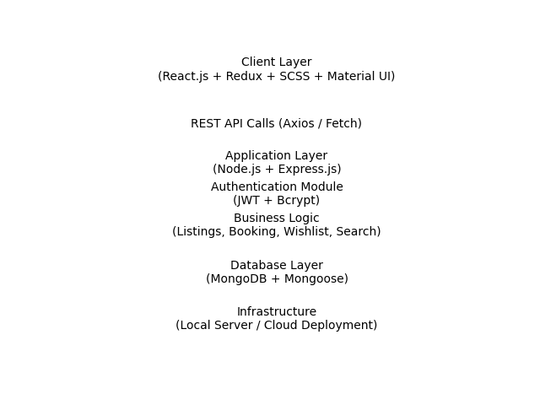

Layer-wise Description
1. Client Layer (Frontend):
- Built using React.js for component-based UI development.
- Redux for global state management (wishlist, user sessions, property data).
- SCSS and Material UI for responsive and modern interface design.
- Handles routing using React Router DOM.
2. Application Layer (Backend):
- Developed using Node.js and Express.js.
- Exposes RESTful APIs for authentication, property management, booking, and user operations.
- Implements middleware for request validation and authorization.
3. Authentication & Security Module:
- JWT-based token authentication for secure session management.
- Bcrypt for password hashing and encryption.
- Environment variables (.env) for secure database configuration.
4. Business Logic Layer:
- Handles property listing creation and management.
- Manages booking workflow using calendar-based selection.
- Implements search and category filtering logic.
- Manages wishlist functionality using Redux state synchronization.
5. Database Layer:
- MongoDB for storing user data, listings, bookings, and wishlist items.
- Mongoose for schema definition, validation, and data modeling.
- Ensures structured and consistent data storage.
6. Infrastructure Layer:
- Can be deployed on local server or cloud hosting platforms.
- Designed to scale with increasing users and property listings.
- Supports future integration with payment gateways and third-party services.

Architecture Benefits
- Secure and scalable MERN stack architecture.
- Clear separation of concerns between frontend, backend, and database.
- Efficient REST API communication.
- High performance with optimized state management.
- Flexible and extensible for future enhancements.

